**INSTALLATION OF PYTHON 3.9.8**

|  |  |
| --- | --- |
| **Date** | 26 OCTOBER 2022 |
| **Team ID** | **PNT2022TMID14537** |
| **Project Name** | GAS LEAKAGE MONITORING AND ALERTING SYSTEM FOR INDUSTRIES |

Step 1: Type python in google and click on the first link

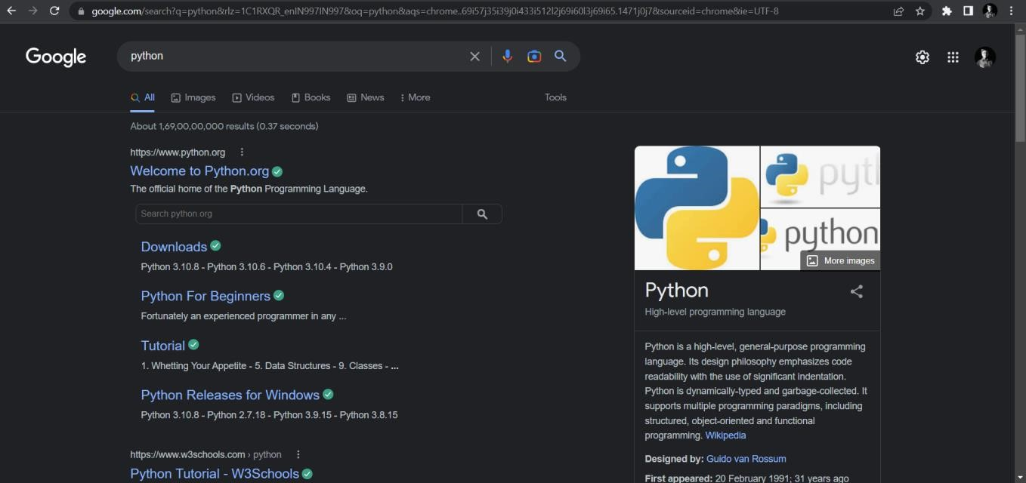

2: Click the python 3.9.8

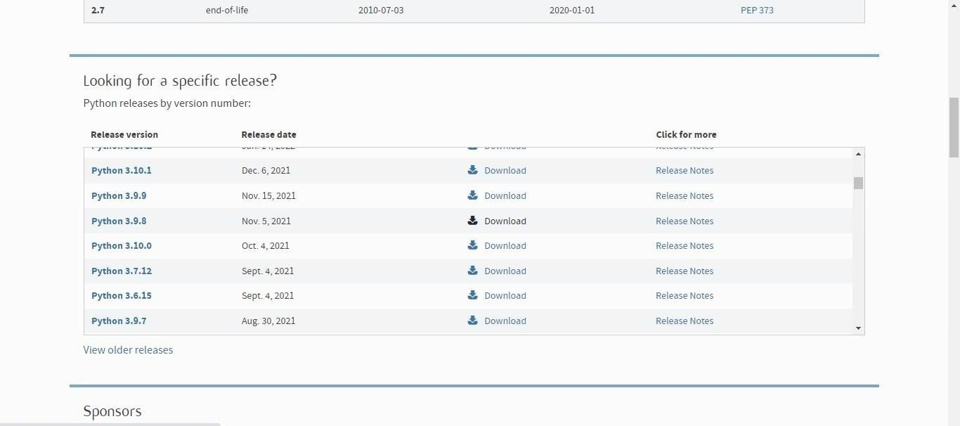

Step 3: Scroll down to reach Files and click on “Window installer (64 bit)

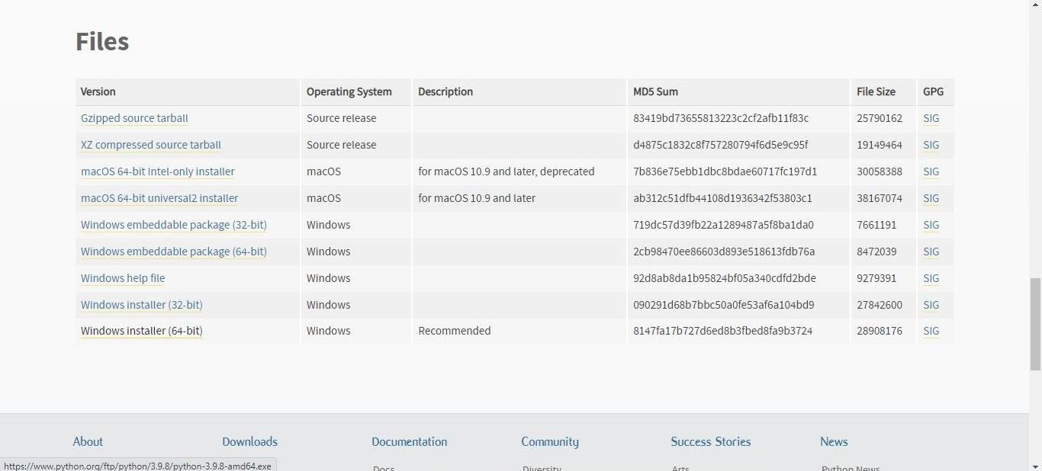

4: Click on the Install button.

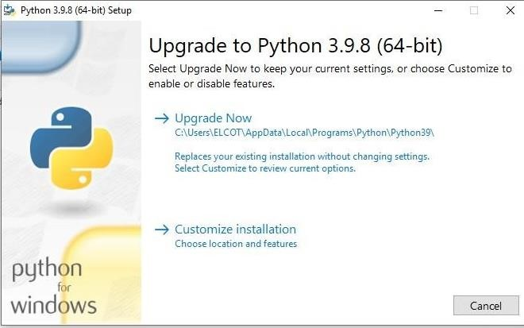

Step 5: Installation on progress

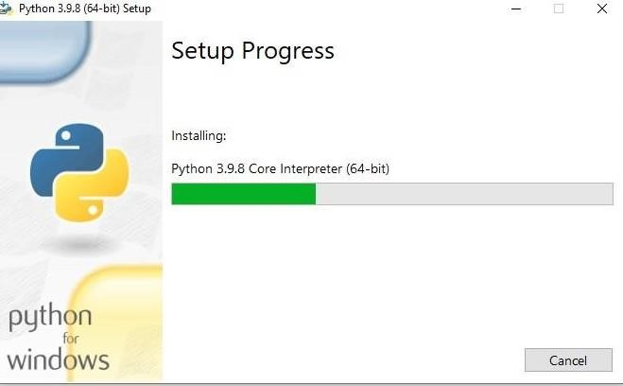

6:Close the button

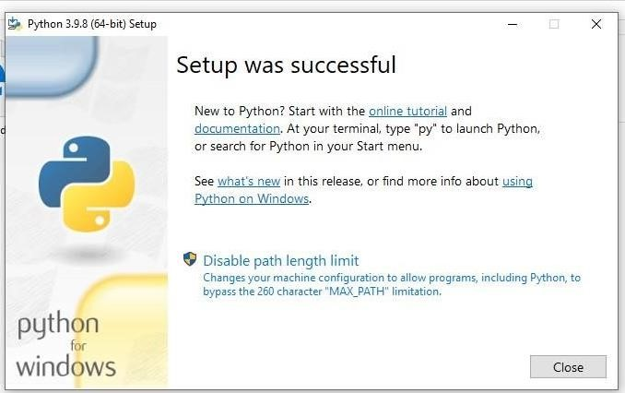

Step 7: Search IDLE

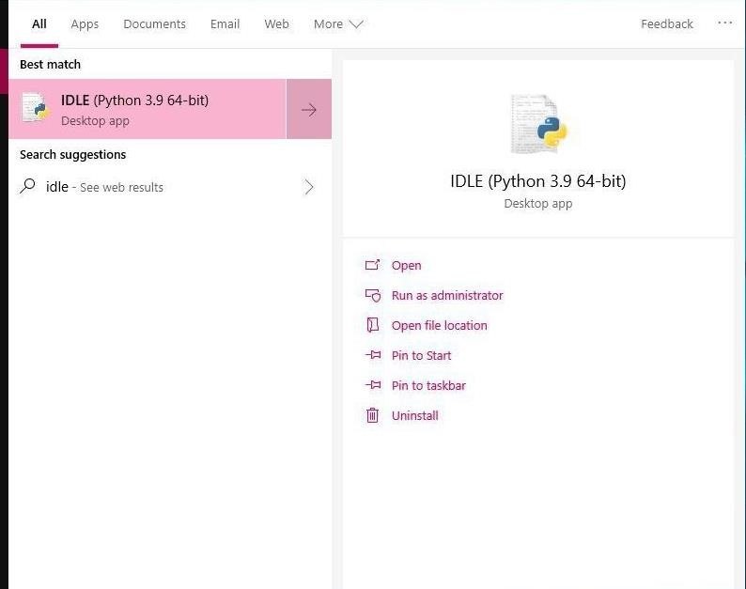

8: Open it

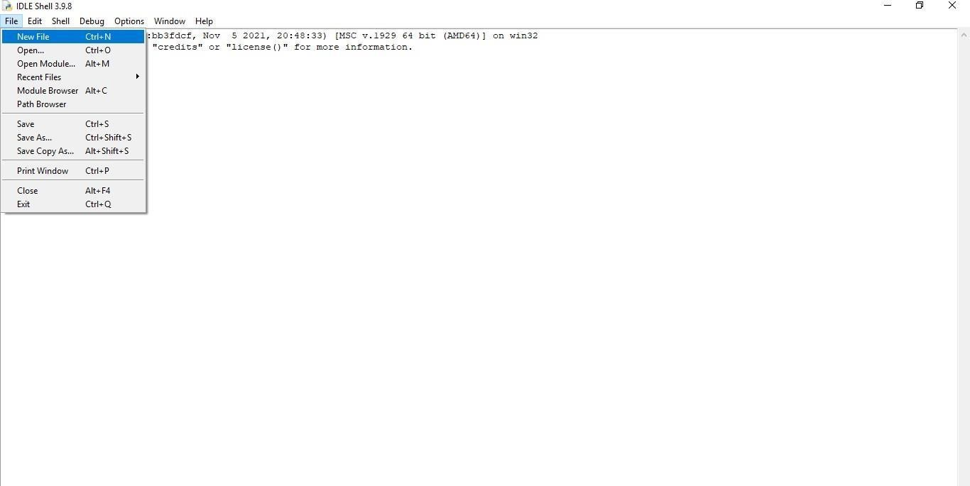

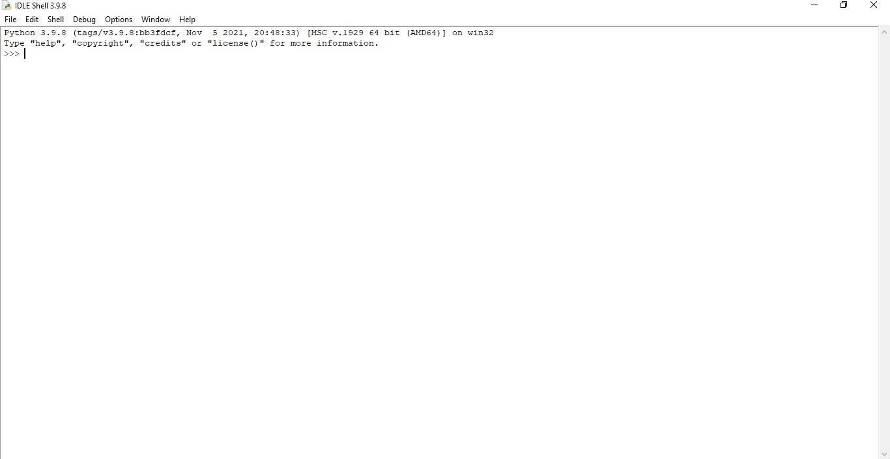

Step 9: Go to file and click on New File

10: Open it

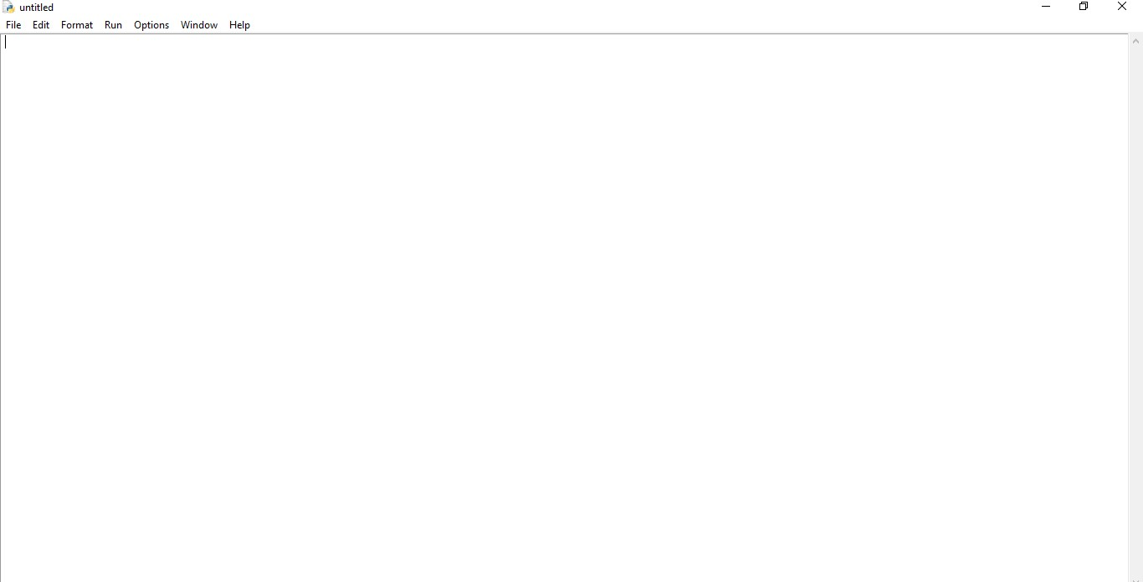

A Python 3.9.8 is installed successfully.